

**I.W.CRITCHLEY & SON**

**Christmas Order Form 2024**

We Wish you a Merry Christmas and a Happy New Year and Thank You for your custom during 2024

Please note that this year because Christmas Day falls on Wednesday we will not be delivering on

**Wednesday 25th and Thursday 26th**

**Orders normally delivered 25TH Will be delivered Mon 23rd**

**Orders normally delivered 26TH Will be delivered Tue 24th**

Over the New year period we will not be delivering

**Wednesday 1st January**

**Orders normally delivered 1st**

**Will be delivered Monday 30th**

**Please return your order form by 16th December 2024 to ensure we can process your order in time.**

NAME: ____________________________

ADDRESS___________________________________

CONTACT INFO ___________________________________

Please enter the **TOTAL** amount you require.

Full product list is available online at

**Critchleymilkdelivery.co.uk**

If you require ***NO EXTRA*** to your normal quantity then you

**do not** need to complete this form. Thank you.

**PLEASE SEE REVERSE**



P

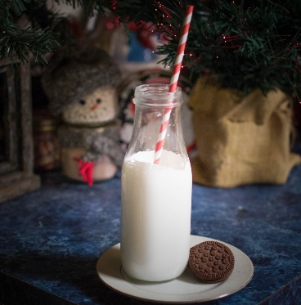

**TEL: 01257 276468 . EMAIL: info@critchleymilkdelivery.co.uk**